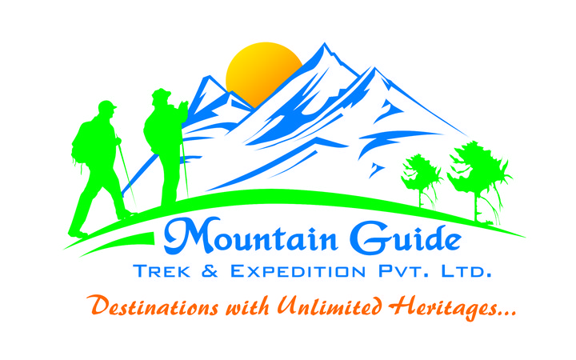 | Mountain Guide  Trek & Expedition Pvt. Ltd.  GPO. Box: 8974 EPC 097  Thamel, Kathmandu, Nepal  Tel: + 977 - 1 – 4442300  Tel/Fax: + 977 – 1 – 4440883  Email: mgt@mail.com.np  info@mountainguidetrek.com  Website: www.mountainguidetrek.com

CREDIT CARD PAYMENT AUTHORISATION LETTER
==============================================

Dear Sir/Madam,

Authorization for the Payment by Credit Card

I would like to pay USD.................
(In words USD .................................................................................................).
For the purchase of........................................................…………
to M/s Mountain Guide Trek & Expedition Pvt. Ltd., Kathmandu, Nepal by my Visa card / Master card. The necessary details for this transaction are as below.

Name of the Cardholder……………………….....................................................
Card Number: ................................... CVV2 No : .............................................
Card Expiry Date: .......................................................
Passport No………………………… Nationality……………..
Card holder's Date of Birth: ............................................................
Address Home: .......................................................................................
Address Office: .............................................................................
Arrival date in Kathmandu………………………..……………...............
Telephone…………………………………...........Fax…………..............................
Email…………………………………….................................................................
Card holder's signature

Attached with this authorization letter are the copy of my credit card (both sides) and the copy of my identification (passport) including the page with my signature.

Thanking you for your kind co-operation.
Regards,
_______________________________________________________________________

Operated under license from the Government of Nepal and Nepal Rastra Bank (Central Bank of Nepal). References are available upon request.

Please print this form, fill all the details completely & sign it (same as in your passport). Scan it and send it to info@mountainguidetrek.com as an attached file or fax us at 977 – 1 - 4440883 along with clear photo copies of the card holder’s passport and the credit card (both sides). A credit card service charge of 3.5 % will be charged on the bill amount paid with credit card.

